**SQL JOIN**

An SQL JOIN clause is used to combine rows from two or more tables, based on a common field between them.

The most common type of join is: **SQL INNER JOIN (simple join)**. An SQL INNER JOIN returns all rows from multiple tables where the join condition is met.

SELECT Orders.OrderID, Customers.CustomerName, Orders.OrderDate

FROM Orders

INNER JOIN Customers

ON Orders.CustomerID=Customers.CustomerID;

**SQL INNER JOIN**

The INNER JOIN keyword selects all rows from both tables as long as there is a match between the columns in both tables.

The INNER JOIN keyword selects all rows from both tables as long as there is a match between the columns. If there are rows in the "Customers" table that do not have matches in "Orders", these customers will NOT be listed.

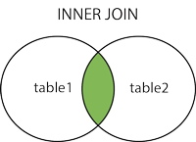

Eg1:

SELECT column_name(s)FROM table1INNER JOIN table2  
ON table1.column_name*=*table2.column_name;

Eg2:

SELECTcolumn_name(s)FROMtable1JOINtable2ONtable1.column_name*=*table2.column_name*;*

EG 3 :

SELECT Customers.CustomerName, Orders.OrderID  
FROM Customers  
INNER JOIN Orders  
ON Customers.CustomerID=Orders.CustomerID  
ORDER BY Customers.CustomerName;

**SQL LEFT JOIN:**

The LEFT JOIN keyword returns all rows from the left table (table1), with the matching rows in the right table (table2). The result is NULL in the right side when there is no match.

The LEFT JOIN keyword returns all the rows from the left table (Customers), even if there are no matches in the right table (Orders).

SELECT column_name(s)FROM table1  
LEFT JOIN table2 *ON*table1.column_name*=*table2.column_name*;*

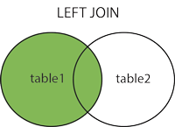

Eg 2:

SELECT Customers.CustomerName, Orders.OrderID  
FROM Customers  
LEFT JOIN Orders  
ON Customers.CustomerID=Orders.CustomerID  
ORDER BY Customers.CustomerName;

**SQL RIGHT JOIN**:

The RIGHT JOIN keyword returns all rows from the right table (table2), with the matching rows in the left table (table1). The result is NULL in the left side when there is no match.

SELECT column_name(s)  
FROM table1  
RIGHT JOIN table2  
ON table1.column_name*=*table2.column_name*;*

In some databases RIGHT JOIN is called RIGHT OUTER JOIN.

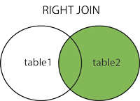

SELECT Orders.OrderID, Employees.FirstName  
FROM Orders  
RIGHT JOIN Employees  
ON Orders.EmployeeID=Employees.EmployeeID  
ORDER BY Orders.OrderID;

The RIGHT JOIN keyword returns all the rows from the right table (Employees), even if there are no matches in the left table (Orders).

## SQL FULL OUTER JOIN Keyword :

The FULL OUTER JOIN keyword returns all rows from the left table (table1) and from the right table (table2).

The FULL OUTER JOIN keyword combines the result of both LEFT and RIGHT joins.

Eg:

SELECT column_name(s)  
FROM table1  
FULL OUTER JOIN table2  
*ON*table1.column_name*=*table2.column_name*;*

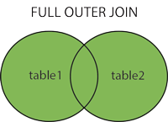

SELECT Customers.CustomerName, Orders.OrderID  
FROM Customers  
FULL OUTER JOIN Orders  
ON Customers.CustomerID=Orders.CustomerID  
ORDER BY Customers.CustomerName;

## The SQL UNION Operator :

The UNION operator is used to combine the result-set of two or more SELECT statements.

Notice that each SELECT statement within the UNION must have the same number of columns. The columns must also have similar data types. Also, the columns in each SELECT statement must be in the same order.

SELECT column_name(s) FROM table1  
UNION  
SELECT column_name(s) FROM table2;

Eg2:

SELECT City FROM Customers  
UNION  
SELECT City FROM Suppliers  
ORDER BY City;